**INERTIAL NAVIGATION SYSTEM**

An inertial navigation system (INS) is a [navigation](https://en.wikipedia.org/wiki/Navigation) device that uses a [computer](https://en.wikipedia.org/wiki/Computer), motion sensors ([accelerometers](https://en.wikipedia.org/wiki/Accelerometer)) and rotation sensors ([gyroscopes](https://en.wikipedia.org/wiki/Gyroscope)) to continuously calculate by [dead reckoning](https://en.wikipedia.org/wiki/Dead_reckoning) the position, the orientation, and the [velocity](https://en.wikipedia.org/wiki/Velocity) (direction and speed of movement) of a moving object without the need for external references.

In [navigation](https://en.wikipedia.org/wiki/Navigation), dead reckoning is the process of calculating one's current position by using a previously determined position, or [fix](https://en.wikipedia.org/wiki/Fix_(position)), and advancing that position based upon known or estimated speeds over elapsed time and course.

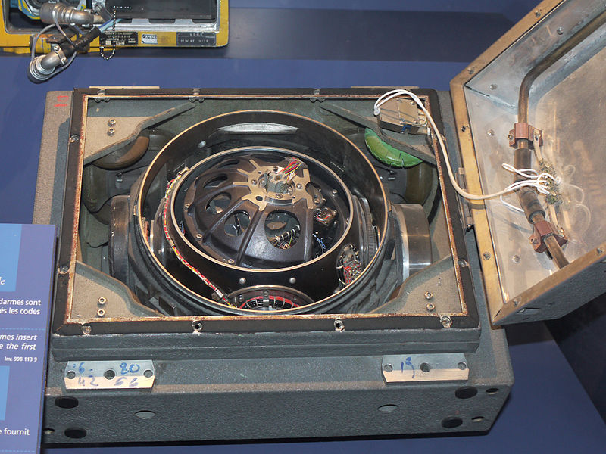

INERTIAL NAVIGATION UNIT OF IRBM S3

**INERTIAL NAVIGATION SYSTEM**

INSs contains [Inertial Measurement Units](https://en.wikipedia.org/wiki/Inertial_Measurement_Unit) (IMUs) which have angular and linear accelerometers (for changes in position);

some IMUs include a gyroscopic element (for maintaining an absolute angular reference).

Angular accelerometers measure how the vehicle is rotating in space.

Generally, there is at least one sensor for each of the three axes: pitch (nose up and down), yaw (nose left and right) and roll (clockwise or counter-clockwise from the cockpit).

Linear accelerometers measure non-gravitational accelerations of the vehicle.

Since it can move in three axes (up & down, left & right, forward & back), there is a linear accelerometer for each axis.

A computer continually calculates the vehicle's current position.

For each of the six [degrees of freedom](https://en.wikipedia.org/wiki/Degrees_of_freedom_(engineering)) (x,y,z and θx, θy and θz), it integrates over time the sensed acceleration, together with an estimate of gravity, to calculate the current velocity.

Then it integrates the velocity to calculate the current position.

INS typically contain three orthogonal rate-gyroscopes and three orthogonal accelerometers, measuring [angular velocity](https://www.sciencedirect.com/topics/engineering/angular-velocity-omega) and linear acceleration respectively.

